List Of updates

1. **Review React and Bootstrap** by creating a **responsive mini project** using the **News API** to reinforce my understanding of Bootstrap classes and React Hooks.
2. **YouTube Tutorial Progress:**

Currently on **Video 8**. I have grasped the **concept of Django backend** and am practicing through this tutorial.

* Create a virtual environment in python and install packages create Django project
* A Django project is essentially a collection of applications like blog users ..
* Admin page create admin user database and migration and create a superuser
* Create own database tables for the application create models and run query using shell and register models
* Working with forms create a user register form and validation flashing messages
* Create form from the UserCreationform using crispy forms tags for the validation tags and errors
* Create a authentication system : Login and logout and redirection so if the user is login show logout in the navbar else login with register
* Creating a page for the user profile

So I’ve knowledge about

**Django views** :handling user requests and rendering responses

**Django urls** : define patterns that match specific URL patterns and route them to corresponding views

**Django template** : like base.html to don't repeat the html code and wrap thr content in block content for other pages

**Django models:** create a basic app model, initialize migrations, and execute them to synchronize your database schema

**Django forms:** like userCreationForm() w add more fields like email fields and crispy form tags to show errors validation and tags

1. About the project on GitHub

* 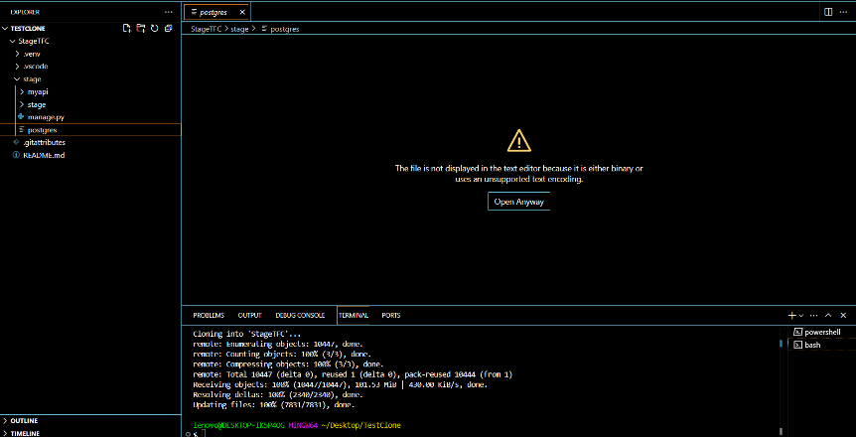I’ve clone the project but i’ve error with this file

**Questions ??**

• **As I see in the createtables file, I need to create tables. Should I create them using PgAdmin as the software?**

• **In the tutorial, they use Bootstrap without React and import templates. In our project, do we have specific templates for React?**

**Next Step :**

* **Complete the YouTube tutorial**
* **Read more about Django** using the recommended website (I’ve start to read the documentation) https://www.geeksforgeeks.org/django-tutorial/
* **Design the database schema** to better understand the project's structure
* **Analyze and run the project** to ensure a clear understanding

I’ve been working consistently and following the planned steps .

I hope I’m doing well. Please let me know if you have any feedback!